Retrospective study on admission trends of Californian Hummingbirds (1991-2016)

Pranav S. Pandit1*ǂ, Ruta R. Bandivadekar2ǂ, Christine K. Johnson1, Nicole Mikoni2, Michelle Mah3, Guthrum Purdin4, Elaine Ibarra5, Duane Tom6, Allison Daugherty4, Max W. Lipman4, Krystal Woo4, Lisa A. Tell2ǂ

1EpiCenter for Disease Dynamics, One Health Institute, School of Veterinary Medicine, University of California, Davis, CA 95616, USA.

2Department of Medicine and Epidemiology, School of Veterinary Medicine, University of California, Davis, CA 95616, USA.

3Department of Wildlife Fish and Conservation Biology, University of California, Davis, CA 95616, USA.

4Lindsay Wildlife Experience, Walnut Creek, CA 94597, USA.

5Santa Barbara Wildlife Care Network, P.O. Box 6594, Santa Barbara, CA 93160, USA

6LAWild, Los Ángeles, CA, USA

*Corresponding Author: Pranav S Pandit; email address: pspandit@ucdavis.edu

ǂContributed equally to this work

**ABSTRACT**

**Background**: Hummingbirds frequently present to California wildlife rehabilitation centers for medical care, accounting for approximately 5% of overall admissions. Age, sex, and reason for admission could impact hummingbird survivability, therefore identification of these factors could help maximize rehabilitation efforts.

**Methods:** Mixed-effects logistic regression models were used to identify specific threats to the survival of 6,908 hummingbirds (1,645 nestlings and 5,263 non-nestlings) consisting of five species (*Calypte anna, Calypte costa, Selasphorus rufous, Selasphorus sasin, Archilochus alexandri*), found in urban settings, and admitted to California wildlife rehabilitation centers over 26 years.

**Results:** In total, 36% of birds survived and were transferred to flight cage facilities for further rehabilitation and/or release. Nestlings were more likely to be transferred and/or released compared to adult hummingbirds. After accounting for age, birds rescued in spring and summer were twice as likely to be released compared to birds rescued in the fall. Nestlings were presented to the rehabilitation centers during spring, which coincides with the nesting season for hummingbirds in California, with the lowest number of nestlings presented in fall. Reasons for presentation to rehabilitation centers included several anthropogenic factors such as window collisions (9.6%) and interactions with domesticated animals (12.9%). Survival odds were lower if a hummingbird was rescued in a “torpor-like state” and were higher if rescued for “nest-related” reasons. Evaluation of treatment regimens administered at wildlife rehabilitation centers identified supportive care, including providing commercial nutrient-rich nectar plus solution, to significantly increase hummingbird survivability.

**Discussion:** Our results provide evidence of threats to hummingbirds in urban habitats, based on reasons for rescue and presentation to rehabilitation centers. Reasons for hummingbird admissions to three California wildlife rehabilitation centers were anthropogenic in nature (i.e., being associated with domestic animals, window collisions, and found inside) and constituted 25% of total admissions. There was a clear indication that supportive care, such as feeding a commercial nectar solution, and medical treatment significantly increased the odds of survival for rescued hummingbirds.

**KEYWORDS**

Anthropogenic threats, *Archilochus alexandri,* *Calypte anna, Calypte costa, Selasphorus rufous, Selasphorus sasin,* Wildlife rehabilitation, Wildlife rescue, California

[1]

Hummingbirds, found only in the Americas, are commonly presented to wildlife rehabilitation centers (Greenewalt 1990; Heyden 2005). These birds are commonly found in urban settings due to the use of human-made feeders, planting of pollinator friendly plants, and/or use of artificial water structures. Understanding the impacts of artificial food-resource provisioning used to attract wildlife in urban areas is gaining increasing importance in wildlife ecology (Bandivadekar et al. 2018; Ditchkoff et al. 2006; Lowry et al. 2013; Ng et al. 2004; Thomas et al. 2014), including hummingbird ecology where artificial sugar water feeders have changed hummingbird population structures in urban gardens (Carpenter 1987). The increased popularity of artificial feeders can rapidly change the composition of avian populations in urban areas (Bradley & Altizer 2007; Robb et al. 2008). Urban gardens with numerous human-provisioned feeders have been found to attract a large number of hummingbirds and increase intra- and inter-species hummingbird interactions during access of these feeders (Bandivadekar et al. 2018). These interactions could increase pathogen transmission within and between species, cause physical injuries, and alter hummingbird behavior. Empirical studies describing disease status and health risks in these urban hummingbird populations are still needed.

Given the increased numbers of hummingbirds attracted to urbanized settings, wildlife centers play a vital role in rehabilitation efforts and provide valuable data for wildlife commonly found in urban habitats (Griffith et al. 2013; Kelly & Bland 2006; Molina-López & Darwich 2011). Standardized medical records documenting success or failure for each wildlife rescue can be crucial in studying spatio-temporal distribution and demographics of wildlife (Heyden 2005; Kelly & Bland 2006; Mazaris et al. 2008; Molina-López & Darwich 2011; Wimberger & Downs 2010). Evaluation of medical records at rehabilitation centers is a commonly utilized method to understand the admission trends, reasons for admission, anthropogenic threats (Deem et al. 1998; Griffith et al. 2013), and pathogen prevalences (Harris & Sleeman 2007) for a wide variety of wildlife species such as bald eagles in the United State and koala bears in Australia. This vast availability of data brings a greater understanding of human-wildlife interactions in our urbanized world, as well as determines the overall impacts and outcomes of rescued wildlife following rehabilitation efforts (Molina-López & Darwich 2011). Increasing numbers of birds are rescued daily and brought to rehabilitation centers (Deem et al. 1998; Molina-López & Darwich 2011; Molina-López et al. 2011), either because of increasing human-animal conflict, increased awareness of the importance of saving individual wild animals and availability of rescue centers in the area, analysis of data collected by rehabilitation centers provide a unique opportunity to understand and mitigate anthropogenic threats to hummingbirds.

To date and to the best of the authors’ knowledge, studies have not yet assessed outcomes for hummingbird rehabilitation. Hummingbird populations in urban settings are known to face a wide variety of anthropogenic threats, including domestic animal interaction, collisions with glass windows, and other manmade structures (Graham 1997; Klem Jr 1989; Loss et al. 2013), and destruction of nesting trees/shrubs. Circumstances that are the basis of hummingbirds’ presentation to rehabilitation centers could affect rehabilitation success and survival. Hence, evaluating anthropogenic threats and other factors such as species, age, and sex is critical for improving rehabilitation success. Furthermore, evaluating treatment option outcomes that increase the chances of successful rehabilitation will help prioritize efforts.

To address factors that impact the success of hummingbird rehabilitation, a retrospective study evaluating trends in presentation, treatment, and eventual disposition from data collected by three California wildlife rehabilitation centers was performed. Our objectives were to investigate the demographics of hummingbirds admitted to wildlife rehabilitation centers, to determine common presenting reasons for these hummingbirds being brought to the wildlife rehabilitation centers, to describe seasonal patterns of admission, and to examine whether age, sex, season, treatment administration, and/or reason for admission of a presented hummingbird influenced their rehabilitation outcome.

**METHODS**

Hummingbirds presented to wildlife rehabilitation centers were reported as nestling/adult on the ground unable to fly, sick, injured, or dead when they were brought into the wildlife rescue centers between January 1st, 1991 through December 31st, 2016. On admission, the rehabilitation center staff collected the following information for each bird: age, sex, species, the reason for admission, date of admission, and the date and place the bird was found. Veterinary technicians or veterinarians completed physical examinations and recorded administered treatments. All data were entered into an online database software called Wildlife Rehabilitation Medical Database (WRMD: <https://www.wrmd.org/>). Data used for the current study was imported from this database for the three rehabilitation centers for the study period. Admission records for hummingbirds presented to Lindsay Wildlife Experience (data for 1991-2016), Santa Barbara Wildlife Rescue Center (data for 2016), and California Wildlife Center, Malibu (data for 2013-2016), all located in California, were used for analysis. Figure 1 illustrates the locations of the rehabilitation centers.

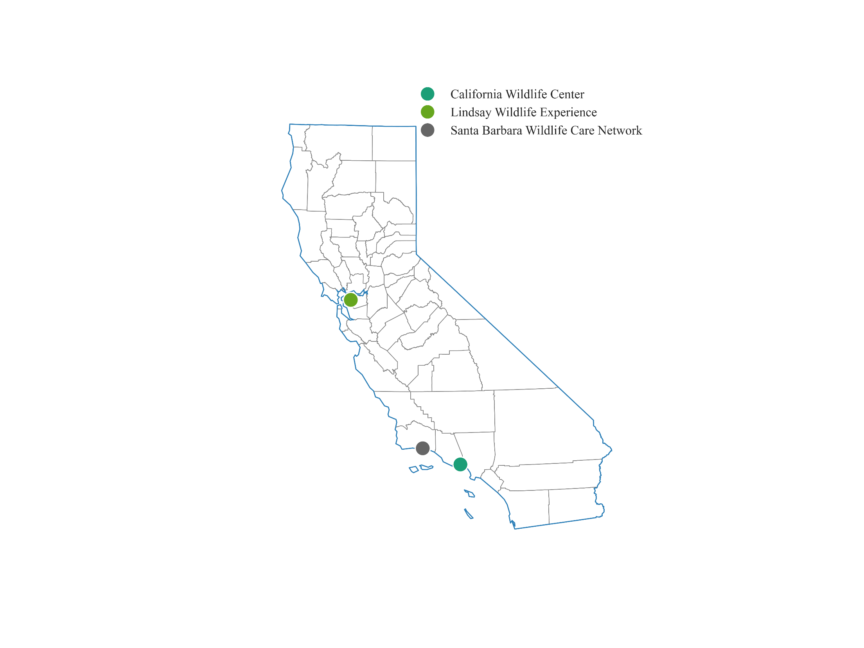

Figure 1: Geographical map of the state of California highlighting the locations of the rehabilitation centers from where the hummingbird rehabilitation data records were obtained for this study (1991 - 2016).

**Standardization of data**

*Hummingbird identification:* The WRMD age data were initially classified into two main categories: “nestling” and “adult-like bird” hummingbirds. All nestlings were considered unknown for sex and species in the study. The adult-like birds were further classified as “*Selasphorus* spp.” and “non-*Selasphorus* spp.” (Russell & Russell 2001). Identification of adult males is less challenging for hummingbird species found in California due to their vibrant, distinct gorget colors compared to their counterpart adult females or young birds (Russell & Russell 2001). For non-*Selasphorus* spp. (Anna’s Hummingbirds [ANHU], Black-Chinned Hummingbirds [BCHU] and Costa’s Hummingbirds [COHU]), records mentioning adult males were assigned “adult-like” and “male” for age and sex respectively. All other non-nestling and non-*Selasphorus* spp. hummingbirds were categorized as “unknown” and “female-like” for age and sex respectively. Similarly, for *Selasphorus* spp., records mentioning adult males (Allen’s Hummingbirds [ALHU] and Rufous Hummingbird [RUHU]) were termed as “adult-like” and “male” for age and sex respectively. All other non-nestling *Selasphorus* spp. hummingbirds were considered “unknown” and “female-like” for age and sex. Lastly, records for hummingbirds without signalment information were categorized as “unknown” for age, sex, and species.

*Reasons for admission:* Reasons for admission data were manually classified into seven categories depending on where and how a hummingbird was found by a good samaritan(s). Two categories were based on the location where the hummingbirds were found. Hummingbirds that were found on a patio, sidewalk, driveway, road, pool, or grass lawn were classified as “found on the ground” whereas hummingbirds that were found inside a human-built structure (e.g. a house, shop, garage, office building) were classified as “found inside”. If a hummingbird was found with a cat, dog, or in one case a chicken, the reason for admission was designated as “associated with domestic animal”. Hummingbirds that were associated with or found in the vicinity of a known nest were identified with the reason of “nest-related”. These included nestlings that were found fallen on the ground but the rescuer had been observing them on a nearby known nest, as well as nestlings that were rescued along with the nest, either where the nest was abandoned by the parents and was easy to extract from the tree/location or where the nesting trees/shrubs were cut down and the nest was found with the nestlings. Hummingbirds that were found at the feeder, usually unresponsive and sitting or hanging upside down, as well as hummingbirds sitting on a bush or fence that people were able to capture with minimal effort, were classified as “torpor-like state”. Another reason for admission included “window collisions” where hummingbirds were brought in after a collision with glass windows, windshields of parked vehicles, and glass doors. Lastly, entries where the reason for admission was not mentioned were classified as “unknown”.

*Supportive measures and treatment provision:* Based on the data available for supportive care and treatment provided, a binary variable (0= treatment not provided, and 1 = treatment provided) was generated. Additional binary variables were created detailing the type of supportive care or treatment including (1) the provision of heat as a supportive measure for possible shock, (2) administration of oral fluids like commercial nectar plus solution as hydration and/or for energy supplementation, and (3) administration of medications like a non-steroidal anti-inflammatory (meloxicam; dose rate 1.0mg/kg on admission to the rehabilitation center and 0.5mg/kg BID for 3–5 days) and steroids (dexamethasone) as well as antibiotic therapy (enrofloxacin; dose 15mg/kg BID 7-10 days). All treatments included in the study were provided by rehabilitation centers.

**Data Analysis**

Since none of the submitted birds had leg bands, all rescued hummingbirds were assumed to be first-time rescues for the purpose of this study. Two mixed-effect logistic regression models were developed to predict the final disposition of hummingbirds (survival or death) during the rehabilitation process. The first model looked at all the individuals while the second model was developed included only a subset of individuals who received preliminary treatment. Survival was defined when birds were transferred to flight cage facilities for further rehabilitation and/or released, or when nestlings were transferred to nurseries and no death or euthanasia was reported by rehabilitation centers. Species and sex groups were included as random effects. Model candidates were fitted and were compared with each other to identify best-fitting models based on AIC and ANOVA test. For the first model (model 1), factors related to demography and whether treatment was provided were tested, and reasons for admissions were explored. A second model predicting survival was developed that included only a subset of individuals whose records indicated that they received preliminary treatment at rehabilitation centers. Binary variables for each treatment option (heat, nectar/oral fluids, steroid, NSAID, antibiotic), were generated to be included in the model. We assumed that reason for admission also accounted for the physical condition of the bird at the time of admission, which may have significantly affected the treatment options. The models were developed in R using the ‘glmmTMB’ package (Brooks et al. 2017). For both models, an interaction term between age and seasons was included and resulting models were tested against the baseline model using the ANOVA test. Ten thousand simulations of the best fitting model 2 were used to predict the probability of survival for all the birds and outcomes were plotted against risk factors categories.

**RESULTS**

**Descriptive statistics of admission records**

A total of 6,908 hummingbirds rescued from 192 city/town areas were presented to the three Californian rehabilitation centers involved in this study over 26 years. There was a distinct trend in the yearly distribution of rescued hummingbirds, with summer, followed by spring, being the most common rescue season and the winter season being the least common (Fig 2a). Of the total birds rescued, 36 % (n = 2,485) were transferred to the flight cage to be returned to a free-ranging environment while the rest included birds that were dead on arrival (5.1%, n = 351), died during the process of rehabilitation (34.8%, n = 2,404), and birds that needed to be euthanized during the process of rehabilitation (24.4%, n = 1,668) (Fig 2b). A total of 5,723 non-*Selasphorus* spp. and 1,185 *Selasphorus* spp. hummingbirds were rescued. Out of 1,645 nestlings, 35.7 % (n = 587) either died or were euthanized, with higher nestling deaths reported between March and June (Fig 2c).

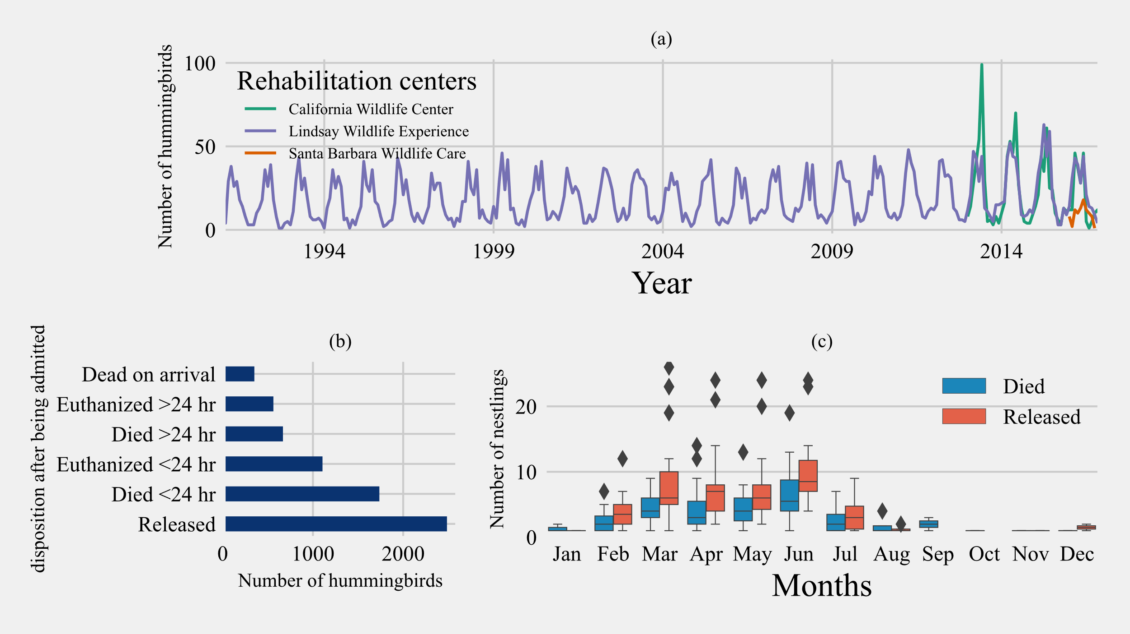

Figure 2: (a) Temporal distribution of the number of birds admitted to California wildlife rehabilitation centers from 1991-2016. (b) Overall disposition distribution for rescued hummingbirds over a period of 26 years. (c) Distribution of nestling disposition by month rescued over 26 years (1991-2016).

For the study period, the most common reason for admission was ‘found on the ground’ at 42.7% (n= 2,950) and at 2.0% (n=135) the least common was “torpor-like state” (Fig 3). 12.9 % of hummingbirds were admitted after being caught by a domestic animal, with most of them being associated with cats except for three instances (2 dogs and 1 companion chicken). This was followed by 13.7% of rescue cases being “nest-related” and 9.6% of cases being associated with “window collisions” (Fig 3). The number of hummingbirds rescued after being “found on the ground” and “caught by domestic animals” showed seasonality components with a higher number of individuals with these reasons for rescue found in early spring to summer seasons. No birds were rescued for “nest-related” reasons between August to December (Fig 4).

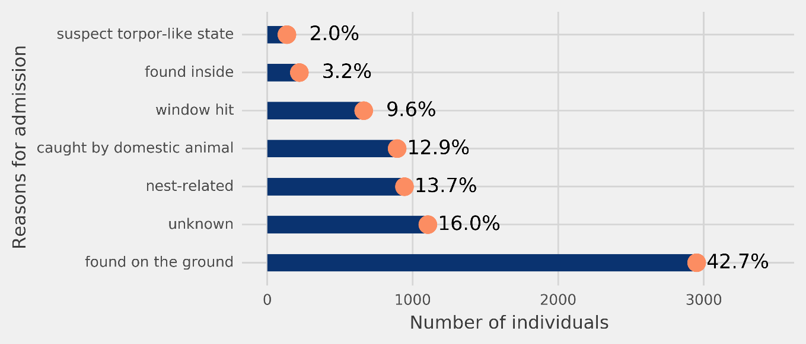

Figure 3: Distribution of the rescued 6,908 hummingbirds from the three Californian-based wildlife rehabilitation centers based on the reason for admission category.

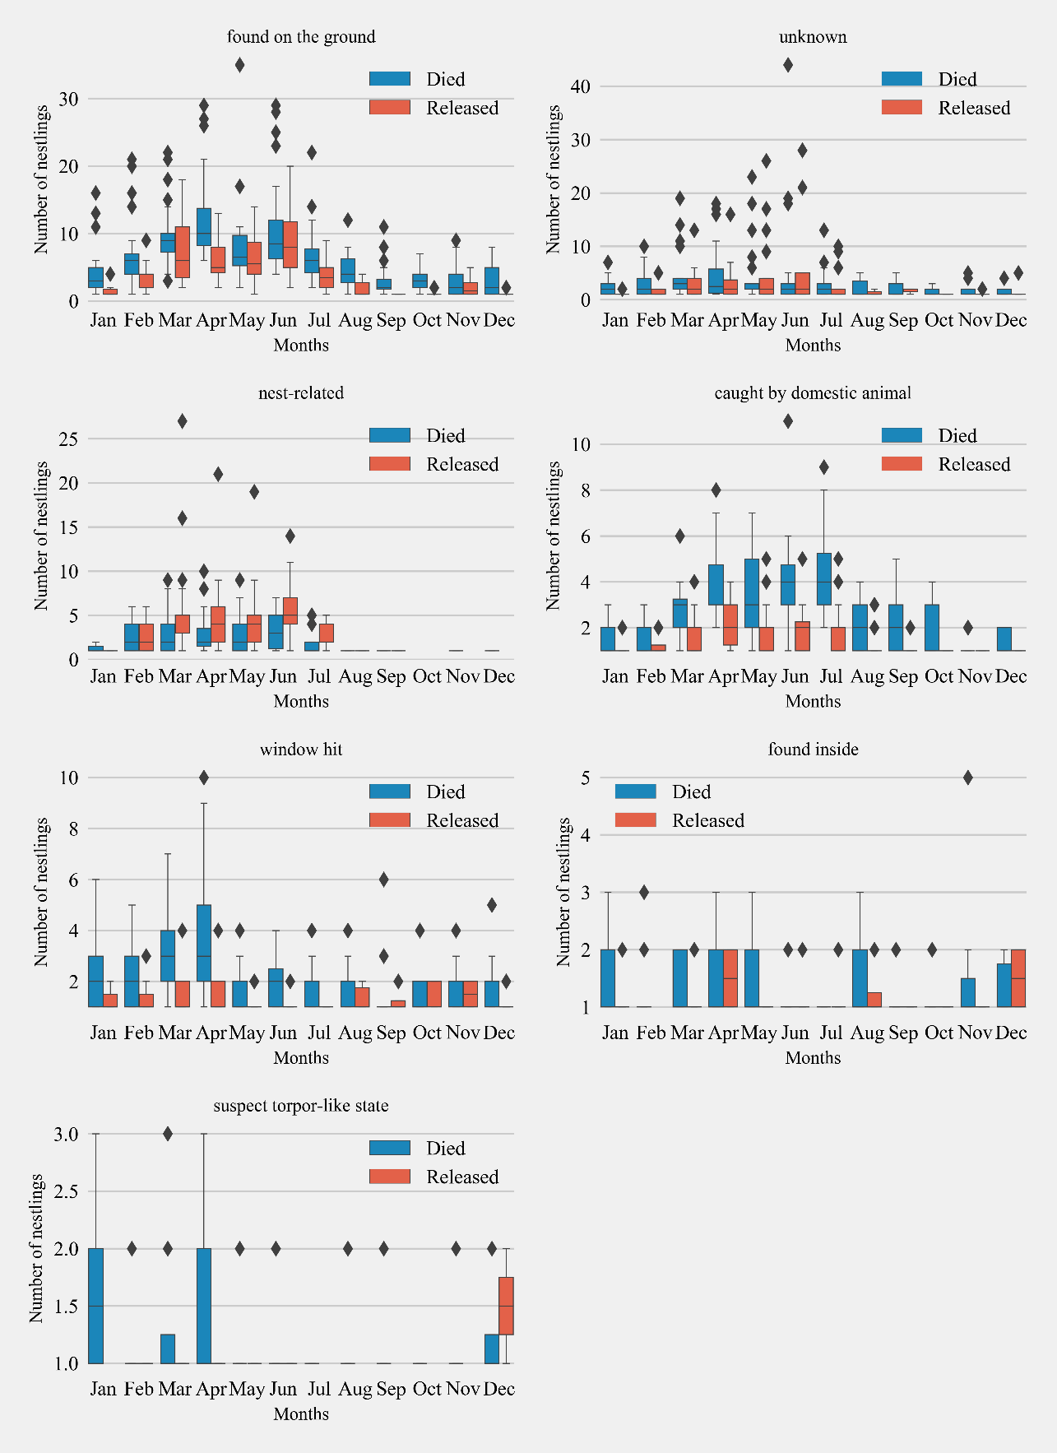

Figure 4: Monthly distribution of hummingbirds admitted to California wildlife rehabilitation centers and their disposition for each admission category (n = 7). Boxplots show the median, first, and third quartiles of the data. Whiskers extend to the data range and outliers are presented as separate diamonds.

A model with age, season, treatment, and reasons for admission as fixed effects was identified as the best fitting model (AIC = 8137.40). Inclusion of an interaction term between age and season significantly improved the model fit (ANOVA Chisq p<0.001, Supplementary Table 1) and resulted in estimates for interactions that were statistically significant. Hence an interaction term for season and age was considered in the final model (model 1, AIC = 8131.2, n = 6,908, Supplementary Table 2). For the model evaluating treatment options (model 2), the inclusion of the interaction term between season and age did not improve the model fit (ANOVA Chisq p = 0.15, Supplementary Table 3), hence no interaction term was included. The subset model evaluating treatment options (model 2) included binary variables for treatment options for heat, nectar/oral fluids, steroid, NSAID, and antibiotic administration along with demographic factors included in the general model (n = 3,779, AIC = 4649.6, Supplementary Table 4).   
 ***Effects of age and season on the release:*** Age was not a significant factor related to survival in the general model (Figure 5). In the model evaluating treatment options (Figure 6), nestlings had 3.43 higher odds of release (CI = 3.57-5.51, p > 0.001). Predicted probability of successful release for nestlings was also significantly higher than adult-like birds (Nestlings: [mean = 0.69, SD±0.056, n = 1,026], adult-like birds: [mean = 0.33, SD±0.178, n = 2,753], Figure 7). Hummingbirds rescued in spring, summer, or winter showed significantly higher odds of release compared with birds rescued in fall (Figure 5-6). In the general model, birds rescued in spring were twice as likely to be released compared to birds rescued in fall (odds ratio: 2.73, CI: 2.12-3.52, p <0.001), while the model evaluating treatment options showed survival odds of 2.61(CI: 1.94-3.53, p <0.001). Birds rescued in summer also showed similar odds to that of birds rescued in spring, and were twice more likely to be released than birds rescued in fall (model 1 = [odds ratio: 2.75, CI: 2.11-3.57, p <0.001], model 2 = [odds ratio: 2.59, CI: 1.90-3.53, p <0.001]). Birds rescued in winter also showed significantly higher odds of survival when compared with birds rescued in fall. (model 1 = [odds ratio: 1.56, CI: 1.17-2.09, p =0.002], model 2 = [odds ratio: 1.50, CI: 1.08-2.10, p =0.016]). Season and age interaction terms included in model 1 showed statistically non-significant odds ratios (Figure 5). Model-predicted probabilities (Figure 7) for birds rescued in various seasons also showed similar trends, with higher probability of release for birds rescued in summer (mean = 0.49, SD±0.160, n = 1,067) and spring (mean = 0.48, SD±0.17, n = 1,763), and least probability of release for birds rescued in fall (mean = 0.19, SD±0.061, n = 333).

***Reasons for admission:*** Hummingbirds that were rescued for reasons related to “torpor-like state” had significantly lower odds of release compared to hummingbirds for which reasons of rescue were unknown (model 1 = [odds ratio: 0.21, CI: 0.11-0.38, p <0.001], model 2 = [odds ratio: 0.15, CI: 0.07-0.34, p <=0.001]). Similarly within model 1, hummingbirds with reason for admission related domestic animals (odds ratio: 0.65, CI: 0.53-0.79, p <0.001), window hit (odds ratio: 0.65, CI: 0.52-0.82, p <0.001), and those which were found on the ground (odds ratio: 0.76, CI: 0.65-0.89, p <0.001) also showed significantly lower odds of release compared to hummingbirds with unknown reason for admission (Figure 5). “Nest-related” birds had the highest predicted probability for successful release compared to other admission reasons (mean = 0.65, SD±0.117, n = 575). The least probability of survival was found in birds rescued in “torpor-like state” (mean = 0.07, SD±0.032, n = 88) followed by “window collisions” (mean = 0.31, SD±0.103, n = 409). The model-predicted probabilities for release are presented in Figure 7.

***Supportive care and treatment:*** Model 1 indicated that provision of supportive treatment, in general, slightly improved the odds of successful hummingbird release (odds ratio: 0.90, CI: 0.80-1.01, p <0.064, Figure 5), but when explored further by parsing out treatments into broad treatment options for select birds that received treatment, model 2 identified treatment options that increased the odds of successful hummingbird release (Figure 6). Hummingbirds that received antibiotics were found to be one and a half times more likely to be released successfully (odds ratio: 1.41, CI: 1.03-1.92, p =0.031) compared to hummingbirds that did not receive antibiotics. Provision of oral fluids also increased the odds of successful release significantly (odds ratio: 1.32, CI: 1.15-1.52, p <0.001). Even after accounting for reasons for admission, hummingbirds that were administered steroids (odds ratio: 0.42, CI: 0.32-0.56, p <0.001) and NSAIDs (odds ratio: 0.74, CI: 0.57-0.96, p =0.021) were found to have reduced odds of survival.

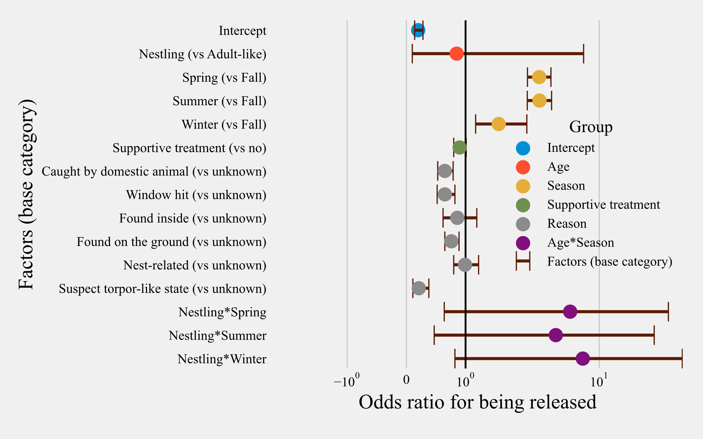

Figure 5: Odds ratios for all risk factors and their confidence intervals for rescued hummingbirds (n = 6,908) with available treatment information. Categories are color-coded according to the group of independent variables.

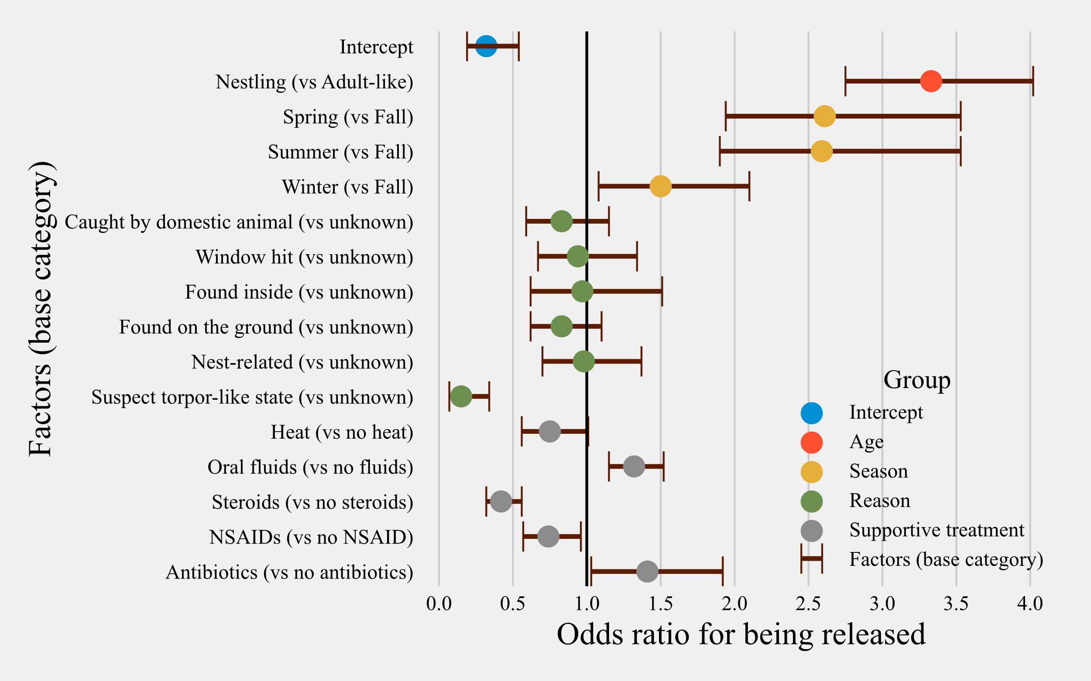

*Figure 6: Odds ratios for all risk factors and their confidence intervals for the subset of hummingbirds with treatment information available in the database (rescued hummingbirds’ n = 3,779). Categories are color-coded according to the group of independent variables.*

*[**Heat= supportive care and/or shock treatment; Oral Fluids= hydration and/or energy supplementation; NSAID= Non-steroidal anti-inflammatory drug; Steroids = Anti-inflammatory and antipyretics]*

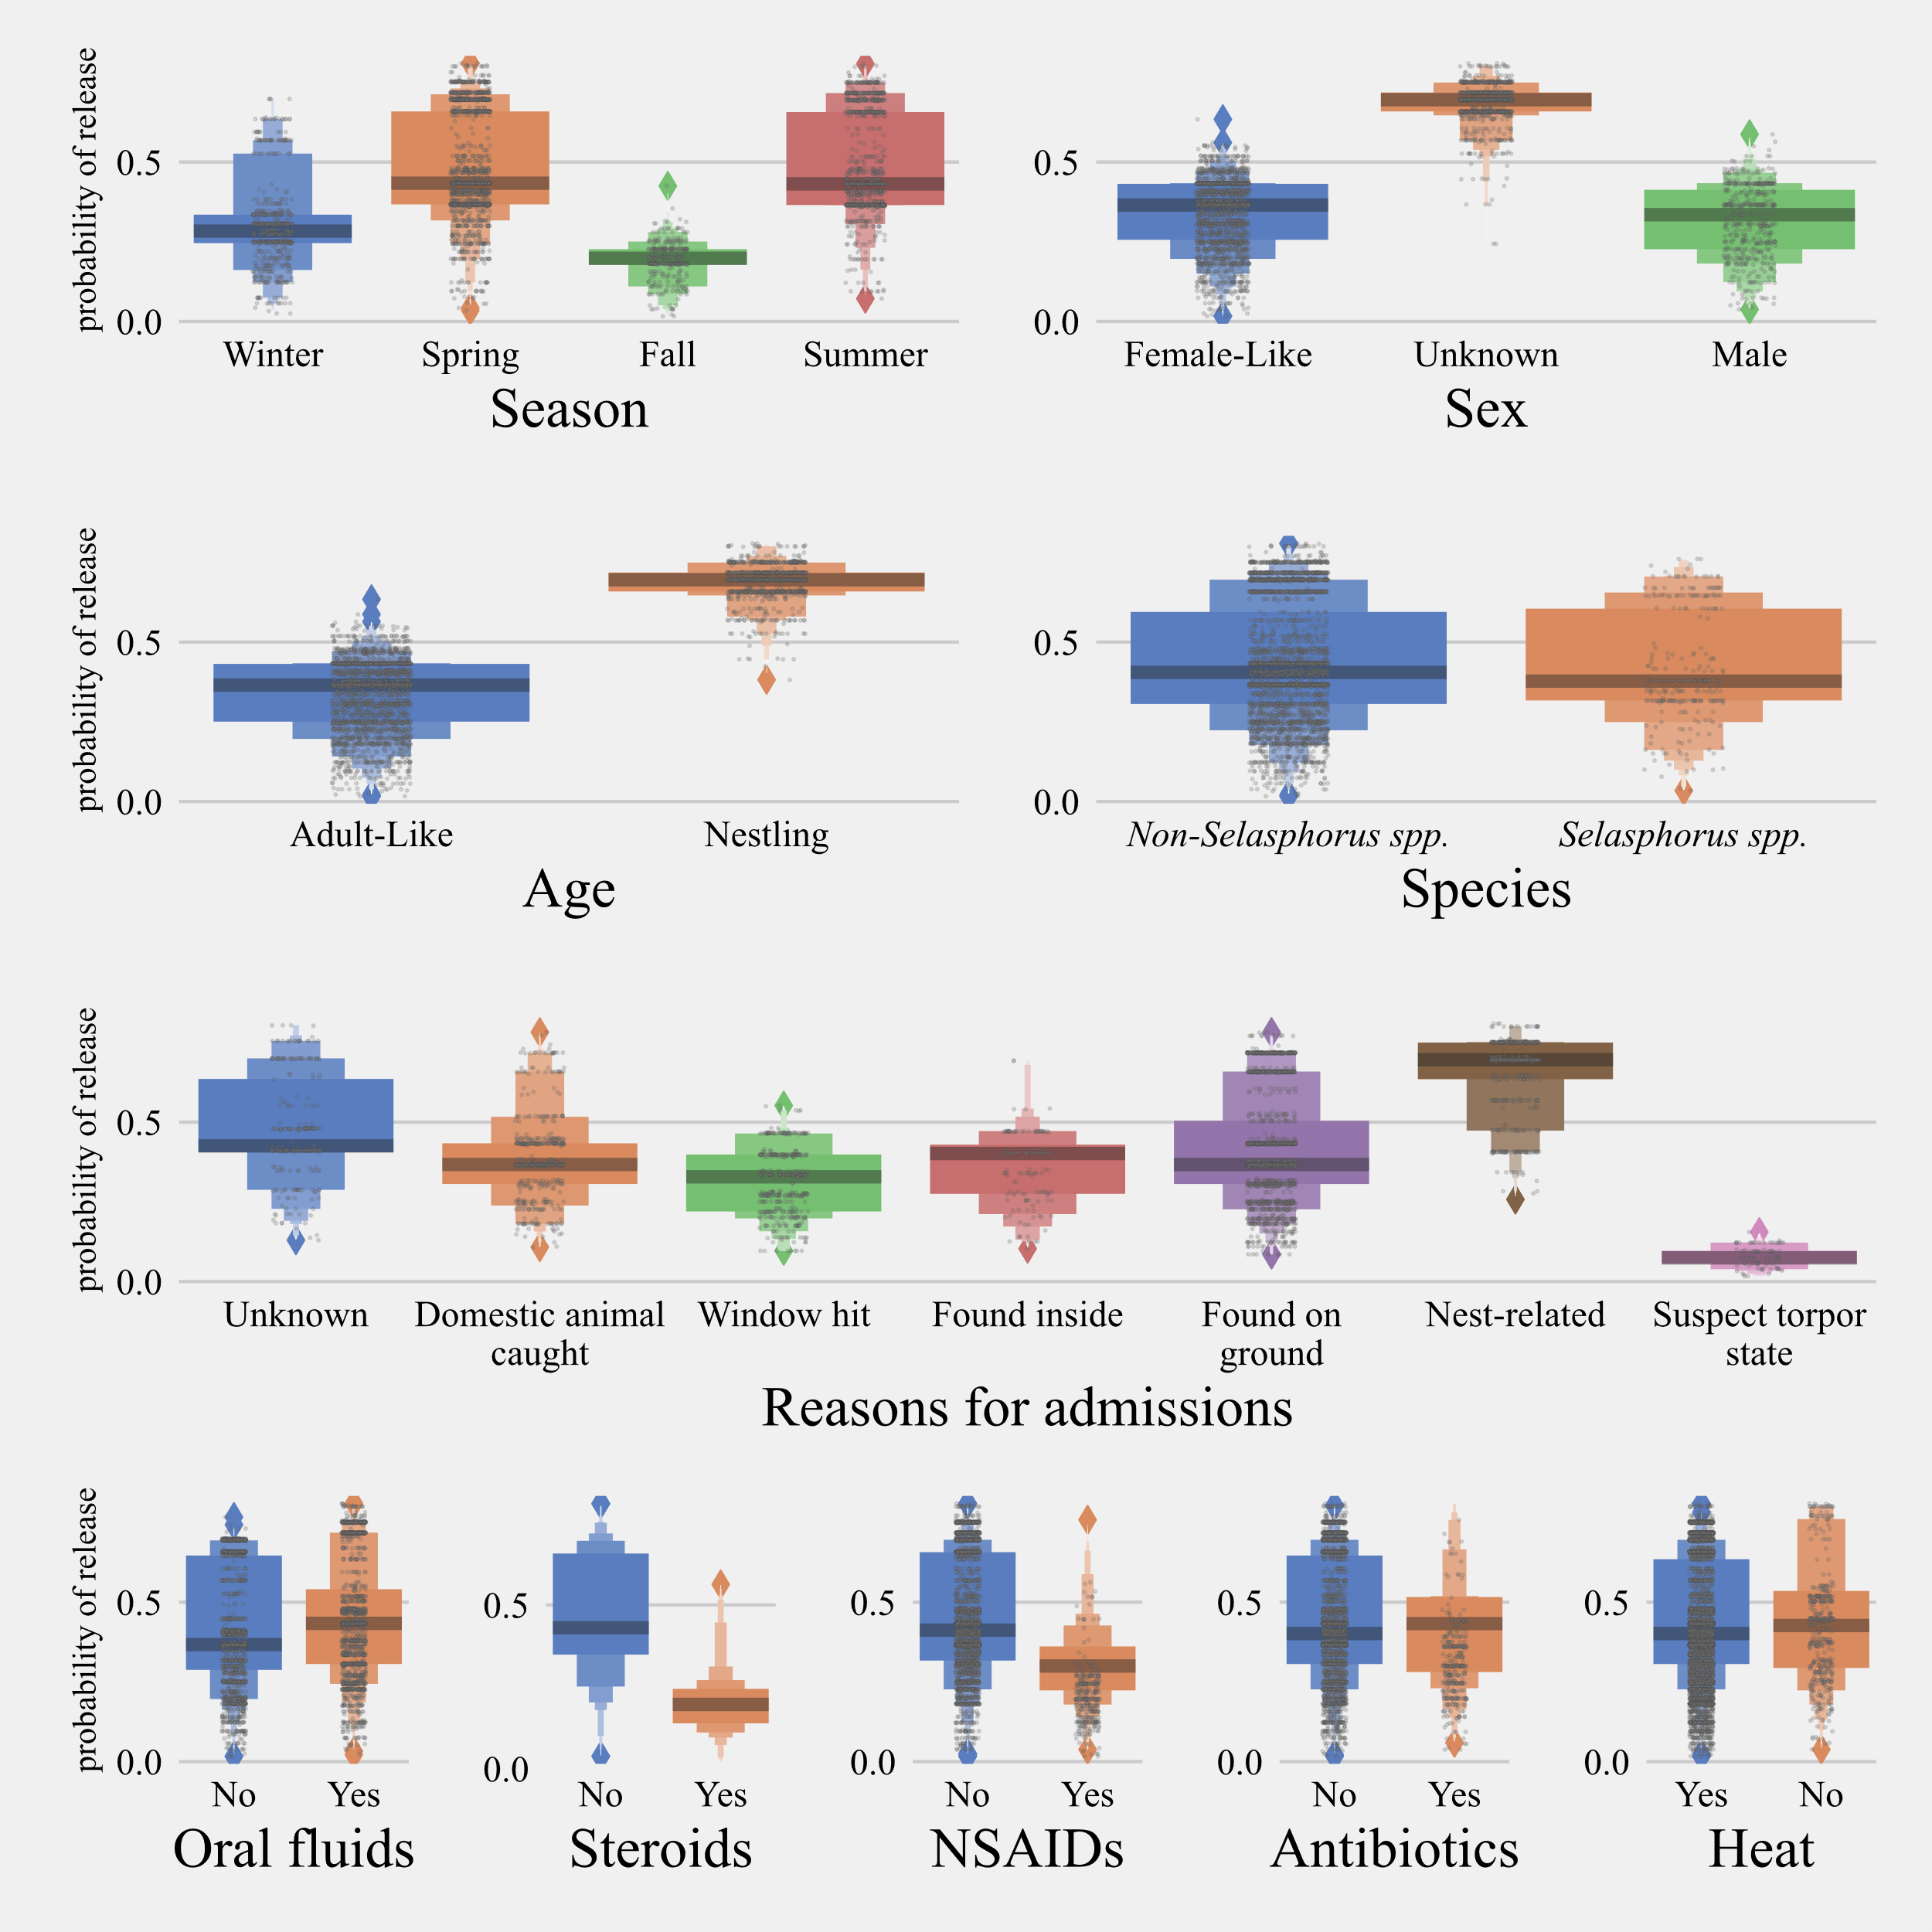

*Figure 7: Distributions of predicted probability using the model vs risk factors for the subset of birds with available treatment information. Boxplots show the median, quartiles, and outliers (diamonds). Each grey dot represents the probability of survival of individual hummingbirds.*

*[Heat= supportive care and/or shock treatment; Oral Fluids= hydration and/or energy supplementation; NSAID= Non-steroidal anti-inflammatory drug; Steroids = Anti-inflammatory and antipyretics]*

**DISCUSSION**

This is the first study to evaluate the survival of urban hummingbirds undergoing rehabilitation and factors that affect survival for this popular group of backyard species. We identified key anthropogenic threats and reasons that hummingbirds found in urban settings were to be admitted to wildlife rehabilitation centers. In evaluating various reasons for hummingbird admissions to three California wildlife rehabilitation centers, several admission categories (such as being associated with domestic animals, window collisions, and found inside, which together constituted 25% of the total admissions) were found to be anthropogenic. We also saw a clear indication that the provision of supportive treatments such as commercial nectar solution can significantly increase the odds of survival of rescued hummingbirds.

Within anthropogenic threats to hummingbirds that were quantifiable, “predator pollution”, or the introduction of domestic species, especially cats (Schenk & Souza 2014), in urban habitats, was one of the key reasons for hummingbirds being rescued and admitted to wildlife rehabilitation centers. Hunting attempts by cats are known to be lethal for birds (Dauphiné & Cooper 2009) and have been known to cause conservation concerns in some hummingbird species in North America (Lepczyk et al. 2004). Given this high mortality rate, public education on the importance of keeping cats indoor-only and reducing the population of free-roaming cats in the environment are both crucial for moving forward (Woods et al. 2003). Belled collars (Ruxton et al. 2002), constructing “catios” (Rudio et. al 2015), using a collar-mounted electronic sonic device (Calver et al. 2007), or restricting the number of cats per household (Heezik et al, 2010) have all been shown to significantly reduce the number of cat predations on birds. Although it cannot be ascertained in our study that being caught by a cat was the primary reason these hummingbirds were admitted into the rehabilitation centers, as the birds could have been down for other reasons (eg. hitting a window and falling on the patio to be eventually found by a house cat), it nevertheless cannot be denied that the large number of admissions under this category was concerning. Campaigns such as the Humane Society of the United States’ “Cats Indoors! The Campaign for Safer Birds and Cats,” local “Trap, Neuter, Release” initiatives, and individual veterinary-client education about keeping owned cats indoors are efforts attempting to move this issue in the right direction and reducing impacts of cats on per-urban avifauna (Burton & Doblar 2004; Schenk & Souza 2014).

Windows and other glass panes around houses and buildings are another major cause of hummingbird injury that led to significantly decreased odds of their successful rehabilitation (odds ratio for rehabilitation 0.94, p>0.05). We observed an increased number of window collisions during early spring which can be associated with the territorial nature of breeding hummingbirds (Graham 1997; Stiles 1982) and the infusion of hummingbird gardens with more aggressive migratory hummingbird species (Dearborn 1998; Klem Jr 1989). Hanging parachute cords (Klem Jr & Saenger 2013), netting or glass etching (Gelb & Delacretaz 2006), use of non-reflective tinted glass (Evans Ogden 1996), and placement of backyard feeders within one meter of windows (Klem Jr 1989; Klem Jr & Saenger 2013) are among various solutions that have been shown to be effective in reducing window collisions. Increasing canopy coverage and, shrub layers in suburban neighborhoods and urban parks, keeping migratory and other biological corridors free of potential hazards such as clear windows and electrical towers, and utilizing darker-pigmented window panes that are more easily avoidable by flighted birds are all ways that humans can do their part in reducing their overall negative impact on hummingbird populations (Schenk & Souza 2014).

Many hummingbirds were also presented to the rehabilitation centers due to reasons related to the destruction of their nests, the third most common reason for presentation. In this study, the “nest-related” category included any nestling that was found on the ground for which repositioning in a nest was not possible, either due to the nest being too high in the tree or the rescuer unable to locate the nest. It also included nestlings that were found with the nest due to either wind blowing them off the tree or the tree was cut down and the nest was found. Lastly, it included nestlings that were brought into the rehabilitation center by observers who could watch the nest regularly (the nest being positioned on a tree right at the level of the window or being built on anthropogenic materials – Christmas lights and decorations, door handles, etc.), who realized they hadn’t seen the hen nearby for a “long time” and therefore assumed the nest had been abandoned. Therefore, “nest-related” hummingbirds, especially young ones, raise the question as to whether or not these birds truly needed human interventions, even though rehabilitators do an initial examination for the dependent nestling to check if the crop has nectar or diet items from the hen in the wildlife to determine if reuniting attempts should be made or not. This concern has been raised by other investigators where a large number of juvenile and newborn wildlife were admitted to rehabilitation centers without injury or obvious cause for rescue outside of the fact that the parent appeared to be away from the young for an “abnormally prolonged” period (Burton & Doblar 2004; Wimberger & Downs 2010). Guidelines that were developed by a hummingbird wildlife rehabilitator for evaluating if a nestling has been abandoned should be consulted before intervention occurs (Greenway 2020).

Hummingbirds found in a “torpor-like” state had the lowest probability of survival (odds ratio 0.45, *p<0.005*). All records that mentioned the rescuer was able to capture the hummingbird without the bird attempting to escape were placed under this category. Hummingbirds can enter a state of torpor due to a variety of underlying reasons, such as physiological reasons, systemic illness, traumatic injury, severe dehydration, hypoglycemia, hypothermia, systemic shock, etc., or restricted energy resources; (Hainsworth et al. 1977). Entering torpor significantly slows the metabolism of these birds and, in turn, slows their ability to combat detrimental factors such as disease or injury (Hainsworth et al. 1977). Given this, and the fact that it was an abnormal time of day for a hummingbird to be in torpor, we hypothesized that hummingbirds admitted in a suspected state of torpor do poorly due to their compromised overall condition.

The number of hummingbirds rescued showed seasonality, with a higher number of individuals presented at rehabilitation centers during the spring (odds ratio 2.76, *p<0.001*) and summer (odds ratio 2.61, *p<0.001*), correlating with the increased number of new nestlings (<https://www.audubon.org/bird-guide>) and first-year breeding individuals (Phillips 1975) similar to trends observed in other bird species (Burton & Doblar 2004; Heyden 2005; Wimberger & Downs 2010). We tested this association by the inclusion of an interaction term between the season and age variables which the models identified as non-significant but significantly improved the model fit predicting survival. The interaction term did not improve the model fit for the model that evaluated treatment (model 2). These results indicate that nestlings have higher odds of successful release than adult-like birds. Along with the increase in nestlings of breeding hummingbird populations, an increase in migratory hummingbird species also contributes to the seasonality of admission trends. Adult Black-chinned Hummingbirds migrate to California for breeding and producing offspring during spring and summer seasons, while Rufous Hummingbirds only migrate through California in spring heading north to their breeding grounds, and again in fall, heading south to their winter grounds in Mexico.

Our results indicated that some simple supportive measures, such as the provision of oral commercial nectar solutions, and as appropriate, antibiotics, can improve survivability during the rehabilitation process. The difficulty in providing medical care to small avian species such as hummingbirds lies in the fact that much is unknown regarding pharmacokinetics and pharmacodynamics of medications and varying metabolic requirements for hummingbirds of varying stages of life (Bucher & Chappell 1989).

For further exploration of the effects of supportive care and treatment on hummingbird survival, standardized data on symptoms, and physical health conditions would significantly help future assessments. Diseases, pesticide exposure/toxicosis (Baek et al. 2020; Bishop et al. 2018; Filigenzi et al. 2019; Godoy et al. 2013; Godoy et al. 2014; Graves et al. 2019; Mikoni et al. 2017), and trauma by other wildlife species, and age all play a role in the overall success of treatment modalities. Those hummingbirds with more extensive injuries due to window collisions or being caught by a cat may be less likely to survive in general due to underlying external and internal trauma, particularly if damage to the skull or beak was sustained (Wimberger & Downs 2010). However, we speculate that the lower survivability of birds receiving stabilizing treatments such as dexamethasone and NSAIDS in traumatic cases might be due to their debilitating physical state rather than drugs that were administered to them. This same thought process also applies to antibiotic administration given that treatment was most likely associated with some type of physical injury. Choice of treatment options is heavily dependent on clinical presentation, degree of physical injury, and shock, and it inherently affects survival chances of hummingbirds. Clinical data at a finer scale describing clinical presentation are needed to elaborate associations of drug choice and hummingbird release success.

Standardization of data collection methods, finer identification of bird species, age and sex, and elimination of data entry biases that get combined by lack of categorization at data entry level are some of the limitations that, once fixed, could help to better understand the rehabilitation of urban hummingbirds. Furthermore, identification of hummingbirds (appropriate speciation, gender, and age distribution) admitted to wildlife rehabilitation centers remains a challenge due to the complexity in the differentiation of species that are female-like in their appearance. Although overall treatment and rehabilitation protocols were not affected by hummingbird species or sex, unidentified categorization of individuals contributes to skewed demographics (age, sex, species). In addition, some of the categories such as “found on ground,” “torpor-like”-state, and “associated with domestic animal”, may have been a secondary rather than the primary cause.

A higher degree of ecological awareness and understanding of the impacts of urbanization on hummingbird populations are key to mitigate future anthropogenic threats (Mazaris et al. 2008). With increasing urbanization of wildlife habitats and human interactions with hummingbirds, analyzing rehabilitation trends of hummingbirds provides insights to better manage the rehabilitation of one of the most charismatic avian groups in California.

**CONCLUSION**

Our results provide evidence of anthropogenic threats to hummingbirds in urban habitats. Anthropogenic reasons for hummingbird admissions such as physical injures due to domestic animals and collisions with windows constituted more than a quarter of cases reported by three Californian rehabilitation centers. We also highlight treatment options that can significantly help improve the rehabilitation success of hummingbirds and We also saw a clear indication that the provision of supportive treatments and medical aids such as the provision of commercial nectar solution can significantly increase the odds of survival of rescued hummingbirds.

**ACKNOWLEDGMENTS**

We would like to thank the following people for their efforts during the completion of this research study: Staff and volunteers at Lindsay Wildlife Experience, California Wildlife Center, and Santa Barbara Wildlife Care Network. Devin Dombrowski and Rachel Avilla for initiating the idea of creating the Wildlife Rehabilitation Medical Database (WRMD) and making it available to Californian Rehabilitation Centers. This study was funded in part by generous support from The Hunter-Jelks Foundation, The James Kralik Charitable Fund, Dr. and Mrs. Grant Patrick, and Dr. and Mrs. Terry Roelofs.

**REFERENCES**

Baek HE, Bandivadekar RR, Pandit P, Mah M, Sehgal RN, and Tell LA. 2020. TaqMan quantitative real-time PCR for detecting Avipoxvirus DNA in various sample types from hummingbirds. *PLoS One* 15:e0230701.

Bandivadekar RR, Pandit PS, Sollmann R, Thomas MJ, Logan SM, Brown JC, Klimley AP, and Tell LA. 2018. Use of RFID technology to characterize feeder visitations and contact network of hummingbirds in urban habitats. *PLoS One* 13:e0208057.

Bishop CA, Moran AJ, Toshack MC, Elle E, Maisonneuve F, and Elliott JE. 2018. Hummingbirds and bumble bees exposed to neonicotinoid and organophosphate insecticides in the Fraser Valley, British Columbia, Canada. *Environmental Toxicology and Chemistry* 37:2143-2152.

Bradley CA, and Altizer S. 2007. Urbanization and the ecology of wildlife diseases. *Trends in Ecology & Evolution* 22:95-102.

Brooks ME, Kristensen K, van Benthem KJ, Magnusson A, Berg CW, Nielsen A, Skaug HJ, Machler M, and Bolker BM. 2017. glmmTMB balances speed and flexibility among packages for zero-inflated generalized linear mixed modeling. *The R journal* 9:378-400.

Bucher TL, and Chappell MA. 1989. Energy metabolism and patterns of ventilation in euthermic and torpid hummingbirds. *Physiology of Cold Adaptation in Birds*: Springer, 187-195.

Burton DL, and Doblar KA. 2004. Morbidity and mortality of urban wildlife in the midwestern United States. Proc 4th International Urban Wildlife Symposium. p 171-181.

Calver M, Thomas S, Bradley S, and McCutcheon H. 2007. Reducing the rate of predation on wildlife by pet cats: The efficacy and practicability of collar-mounted pounce protectors. *Biological Conservation* 137:341-348.

Carpenter FL. 1987. Food abundance and territoriality: to defend or not to defend? *American Zoologist* 27:387-399.

Dauphiné N, and Cooper RJ. 2009. Impacts of free-ranging domestic cats (Felis catus) on birds in the United States: a review of recent research with conservation and management recommendations. Proceedings of the fourth international partners in flight conference: tundra to tropics.

Dearborn DC. 1998. Interspecific territoriality by a rufous-tailed hummingbird (Amazilia tzacatl): effects of intruder size and resource value. *Biotropica* 30:306-313.

Deem SL, Terrell SP, and Forrester DJ. 1998. A retrospective study of morbidity and mortality of raptors in Florida: 1988-1994. *Journal of Zoo and Wildlife Medicine* 29:160-164.

Ditchkoff SS, Saalfeld ST, and Gibson CJ. 2006. Animal behavior in urban ecosystems: modifications due to human-induced stress. *Urban Ecosystems* 9:5-12.

Evans Ogden LJ. 1996. Collision course: the hazards of lighted structures and windows to migrating birds. *Fatal Light Awareness Program (FLAP)*:3.

Filigenzi MS, Graves EE, Tell LA, Jelks KA, and Poppenga RH. 2019. Quantitation of neonicotinoid insecticides, plus qualitative screening for other xenobiotics, in small-mass avian tissue samples using UHPLC high-resolution mass spectrometry. *Journal of Veterinary Diagnostic Investigation* 31:399-407.

Gelb Y, and Delacretaz N. 2006. Avian window strike mortality at an urban office building. *The Kingbird* 56:190-198.

Godoy LA, Dalbeck LS, Tell LA, Woods LW, Colwell RR, Robinson B, Wethington SM, Moresco A, Woolcock PR, and Ernest HB. 2013. Characterization of avian poxvirus in Anna's Hummingbird (Calypte anna) in California, USA. *Journal of Wildlife Diseases* 49:978-985. <http://dx.doi.org/10.7589/2012-09-230>

Godoy LA, Tell LA, and Ernest HB. 2014. Hummingbird health: pathogens and disease conditions in the family Trochilidae. *Journal of ornithology / DO-G* 155:1-12. <http://dx.doi.org/10.1007/s10336-013-0990-z>

Graham DL. 1997. Spider Webs and Windows as Potentially Important Sources of Hummingbird Mortality (Telas de Araña y Ventanas Como Fuentes Potenciales de Mortalidad para Zumbadores). *Journal of Field Ornithology*:98-101.

Graves EE, Jelks KA, Foley JE, Filigenzi MS, Poppenga RH, Ernest HB, Melnicoe R, and Tell LA. 2019. Analysis of insecticide exposure in California hummingbirds using liquid chromatography-mass spectrometry. *Environmental Science and Pollution Research* 26:15458-15466.

Greenewalt CH. 1990. *Hummingbirds*: Courier Corporation.

Greenway MK. 2020. *If Hummingbirds Could Hum*: G2 Books.

Griffith JE, Dhand NK, Krockenberger MB, and Higgins DP. 2013. A retrospective study of admission trends of koalas to a rehabilitation facility over 30 years. *Journal of Wildlife Diseases* 49:18-28.

Hainsworth FR, Collins BG, and Wolf LL. 1977. The function of torpor in hummingbirds. *Physiological Zoology* 50:215-222.

Harris MC, and Sleeman JM. 2007. Morbidity and mortality of bald eagles (Haliaeetus leucocephalus) and peregrine falcons (Falco peregrinus) admitted to the Wildlife Center of Virginia, 1993–2003. *Journal of Zoo and Wildlife Medicine* 38:62-67.

Heyden KG. 2005. A comparison of avian data from two wildlife rehabilitation centers in Indiana: an honors thesis (HONRS 499).

Kelly A, and Bland M. 2006. Admissions, diagnoses, and outcomes for Eurasian sparrowhawks (Accipiter nisus) brought to a wildlife rehabilitation center in England. *Journal of Raptor Research* 40:231-236.

Klem Jr D. 1989. Bird: window collisions. *The Wilson Bulletin*:606-620.

Klem Jr D, and Saenger PG. 2013. Evaluating the effectiveness of select visual signals to prevent bird-window collisions. *The Wilson Journal of Ornithology* 125:406-411.

Lepczyk CA, Mertig AG, and Liu J. 2004. Landowners and cat predation across rural-to-urban landscapes. *Biological Conservation* 115:191-201. 10.1016/S0006-3207(03)00107-1

Loss SR, Will T, and Marra PP. 2013. The impact of free-ranging domestic cats on wildlife of the United States. *Nature Communications* 4:1396.

Lowry H, Lill A, and Wong BB. 2013. Behavioural responses of wildlife to urban environments. *Biological Reviews* 88:537-549.

Mazaris AD, Mamakis Y, Kalpakis S, Poulopoulos Y, and Matsinos YG. 2008. Evaluating potential threats to birds in Greece: an analysis of a 10-year data set from a rehabilitation centre. *Oryx* 42:408-414.

Mikoni NA, Poppenga R, Ackerman JT, Foley J, Hazlehurst J, Purdin G, Aston L, Hargrave S, Jelks K, and Tell LA. 2017. Trace element contamination in feather and tissue samples from Anna's hummingbirds. *Ecological Indicators* 80:96-105. 10.1016/j.ecolind.2017.04.053

Molina-López R, and Darwich L. 2011. Causes of admission of little owl (Athene noctua) at a wildlife rehabilitation centre in Catalonia (Spain) from 1995 to 2010. *Animal Biodiversity and Conservation* 34:401-405.

Molina-López RA, Casal J, and Darwich L. 2011. Causes of morbidity in wild raptor populations admitted at a wildlife rehabilitation centre in Spain from 1995-2007: a long term retrospective study. *PLoS One* 6:e24603.

Ng SJ, Dole JW, Sauvajot RM, Riley SP, and Valone TJ. 2004. Use of highway undercrossings by wildlife in southern California. *Biological Conservation* 115:499-507.

Phillips AR. 1975. MIGRATIONS OF ALLENS AND OTHER HUMMINGBIRDS. *Condor* 77:196-205. 10.2307/1365790

Robb GN, McDonald RA, Chamberlain DE, and Bearhop S. 2008. Food for thought: supplementary feeding as a driver of ecological change in avian populations. *Frontiers in Ecology and the Environment* 6:476-484.

Russell SM, and Russell RO. 2001. *The North American banders' manual for banding hummingbirds*: North American Banding Council.

Ruxton GD, Thomas S, and Wright JW. 2002. Bells reduce predation of wildlife by domestic cats (Felis catus). *Journal of Zoology* 256:81-83.

Schenk AN, and Souza MJ. 2014. Major anthropogenic causes for and outcomes of wild animal presentation to a wildlife clinic in East Tennessee, USA, 2000–2011. *PLoS One* 9:e93517.

Stiles FG. 1982. Aggressive and courtship displays of the male Anna's Hummingbird. *The Condor* 84:208-225.

Thomas RL, Baker PJ, and Fellowes MD. 2014. Ranging characteristics of the domestic cat (Felis catus) in an urban environment. *Urban Ecosystems* 17:911-921.

Wimberger K, and Downs C. 2010. Annual intake trends of a large urban animal rehabilitation centre in South Africa: a case study. *Animal Welfare* 19:501.

Woods M, McDonald RA, and Harris S. 2003. Predation of wildlife by domestic cats Felis catus in Great Britain. *Mammal Review* 33:174-188.

1. Email: [pspandit@ucdavis.edu](mailto:pspandit@ucdavis.edu)

   2 Current affiliation: EpiCenter for Disease Dynamics, One Health Institute, School of Veterinary Medicine, University of California, Davis, CA 95616, USA.